# ST.XAVIER’S COLLEGE

# MAITIGHAR, KATHMANDU



**LAB ASSIGNMENT #1**

**Computer Graphics**

**Submitted By:**

Prashraya Hada

012BSCCSIT027

4TH Sem, 2nd Year

**Submitted To:**

______________________

Er.Anil K Sah

Lecturer

Department of Computer Science

**Lab Assignment 1.b**

Draw the following checkbox.

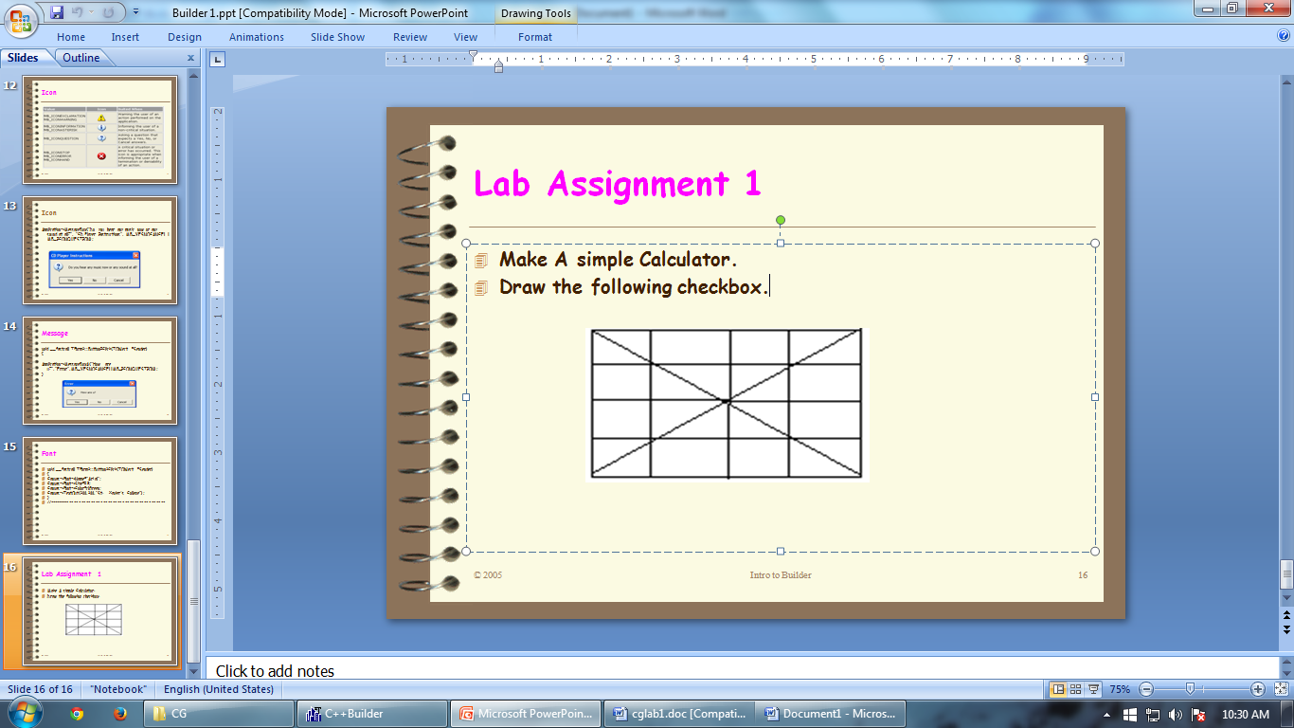

**Source Code:**

//---------------------------------------------------------------------------

#include <vcl\vcl.h>

#pragma hdrstop

#include "box.h"

//---------------------------------------------------------------------------

#pragma resource "*.dfm"

TForm1 *Form1;

//---------------------------------------------------------------------------

__fastcall TForm1::TForm1(TComponent* Owner)

: TForm(Owner)

{

Image1->Canvas->MoveTo(10,10);

Image1->Canvas->LineTo(210,210);

Image1->Canvas->MoveTo(210,10);

Image1->Canvas->LineTo(10,210);

Image1->Canvas->MoveTo(60,10);

Image1->Canvas->LineTo(60,210);

Image1->Canvas->MoveTo(110,10);

Image1->Canvas->LineTo(110,210);

Image1->Canvas->MoveTo(160,10);

Image1->Canvas->LineTo(160,210);

Image1->Canvas->MoveTo(10,60);

Image1->Canvas->LineTo(210,60);

Image1->Canvas->MoveTo(10,110);

Image1->Canvas->LineTo(210,110);

Image1->Canvas->MoveTo(10,160);

Image1->Canvas->LineTo(210,160);

Image1->Canvas->MoveTo(10,210);

Image1->Canvas->LineTo(210,210);

Image1->Canvas->MoveTo(210,10);

Image1->Canvas->LineTo(210,210);

Image1->Canvas->MoveTo(10,10);

Image1->Canvas->LineTo(210,10);

Image1->Canvas->MoveTo(10,10);

Image1->Canvas->LineTo(10,210);

}

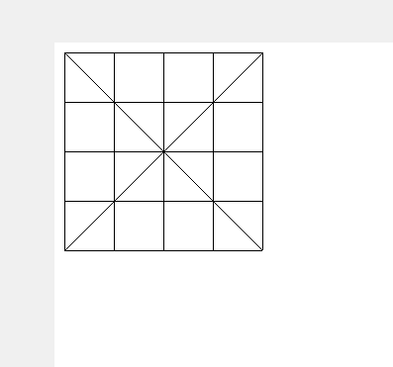**OUTPUT:**